
./
Power Window Report

Course Code: <CODE>


Version Number:
Module: Model Based System Engineering

Ver. Rel. No. | Release Date | Prepared. By | Reviewed By | Approved By | Remarks/Revision Details
1 | 18/03/2021 | Arnav Kandpal (99003730)
Document History

Contents

1 -A brief introduction to power window………………………………………………………..1
2 -Power Window Switch configuration 3
Activity 3 - Complete Simulink Onramp 4
Activity 4 - Complete Statefow Onramp 5

A Brief Introduction to Power Windows:
Power windows have a structure much like the hand powered or manual windows. The difference is the handle bars are replaced with motor and the motion is now actuated with the actuator or power circuit thus the name “Power Window”.
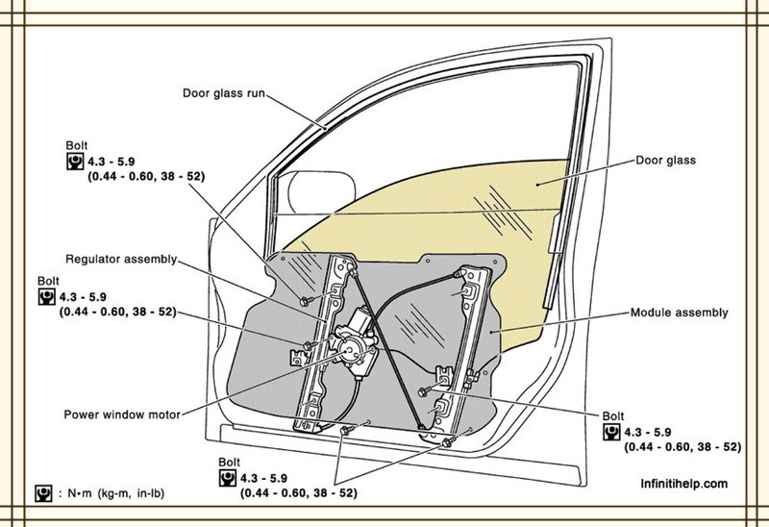
Figure1: Power Window motor Configuration.

2)Power Window Switch Configuration:

Power window switch configuration is generally as Follows:
- 5- Switches on driver side (4 Window Switch and 1 Disable Passenger Switch)
- 1 switch each on rest of the remaining doors
- Total of 7 Switches.

Driver Power Window Switch: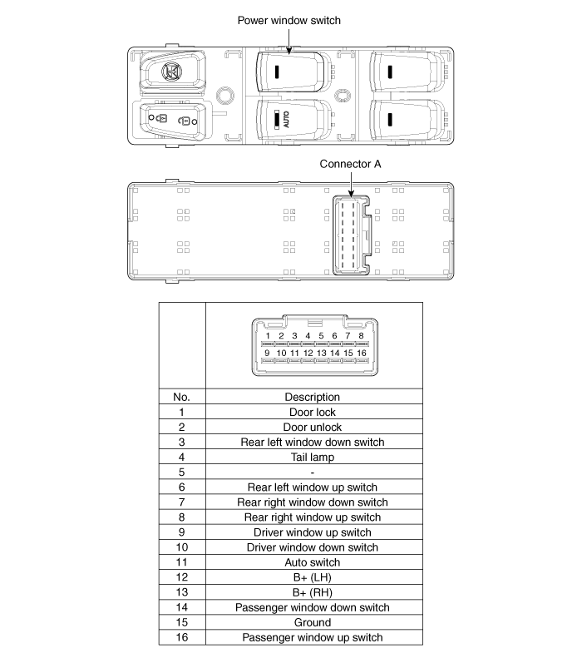
Passenger Power Window Switch
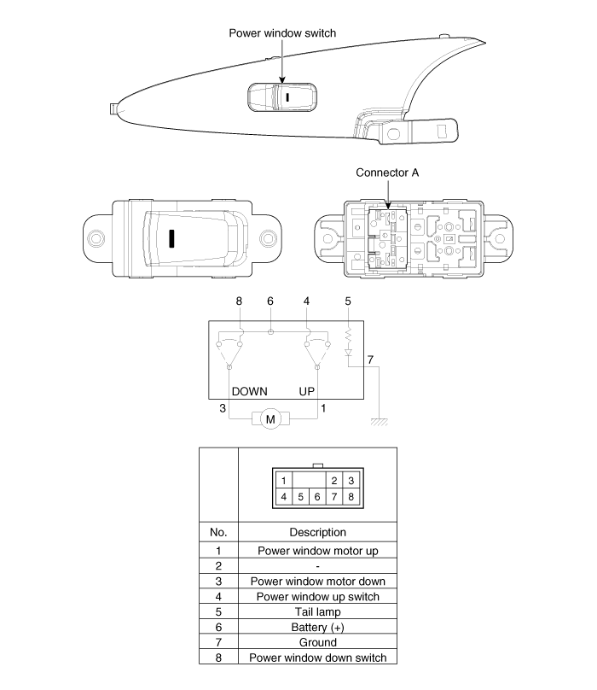
Rear Power Window Switch
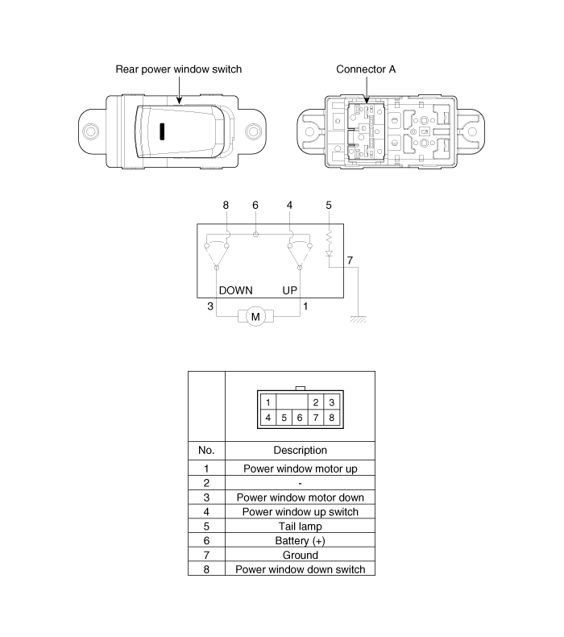

3)Internal Circuitry of power windows:
Here is the internal circuitry for GMC Sierra for an instance of communication between driver switch, passenger switch, and the window pane to control.
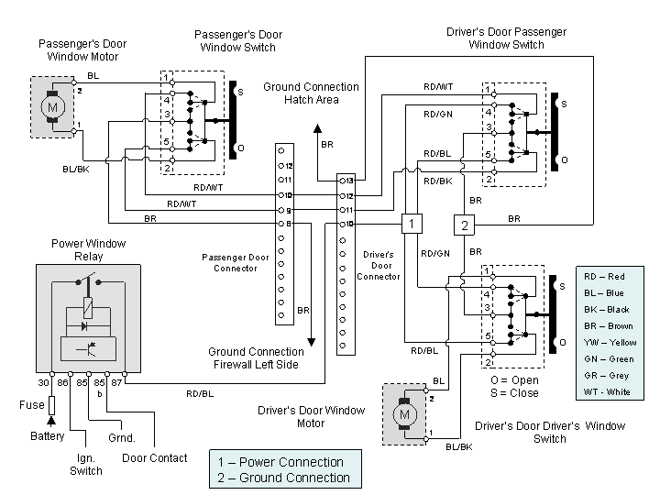

4)IC used in power circuit switched
Many different types of ic’s can be used in the power window operation but we will be focusing on the KA3903 as it supports 2 different mode for same motor which would be useful for the express mode and normal mode operation.
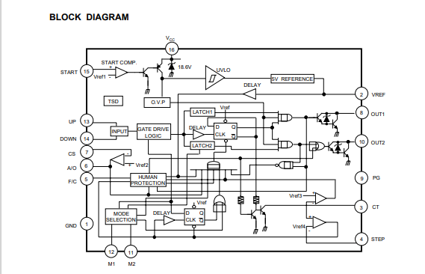
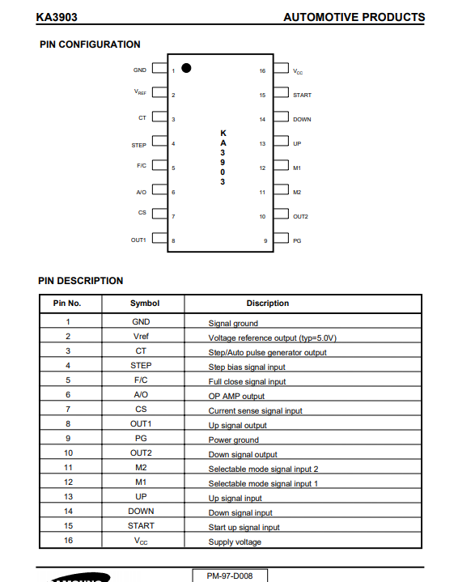
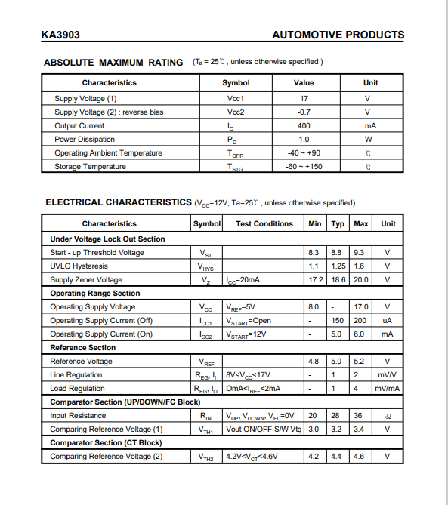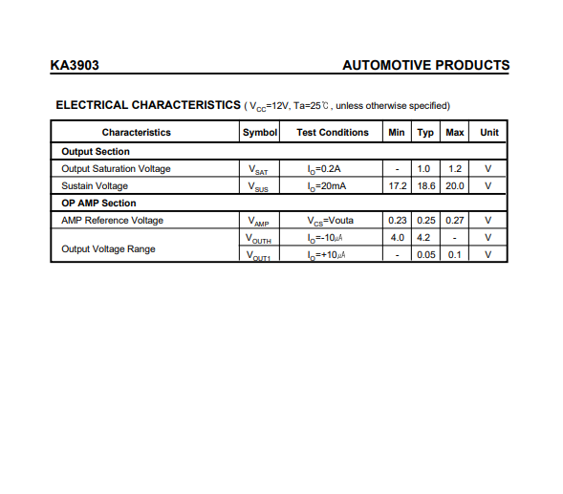

5)Motor Specs:

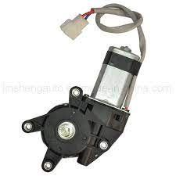
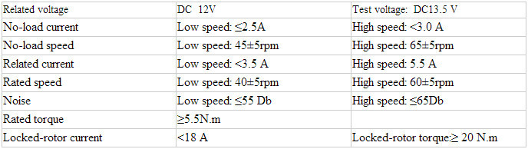

6)Anti-Pinch Feature:

Algorithm:
- Equation:
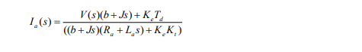

- Block Diagram:
